### **TARGET CUSTOMER BASE/MARKET SIZING**

#### Demographics by age and gender

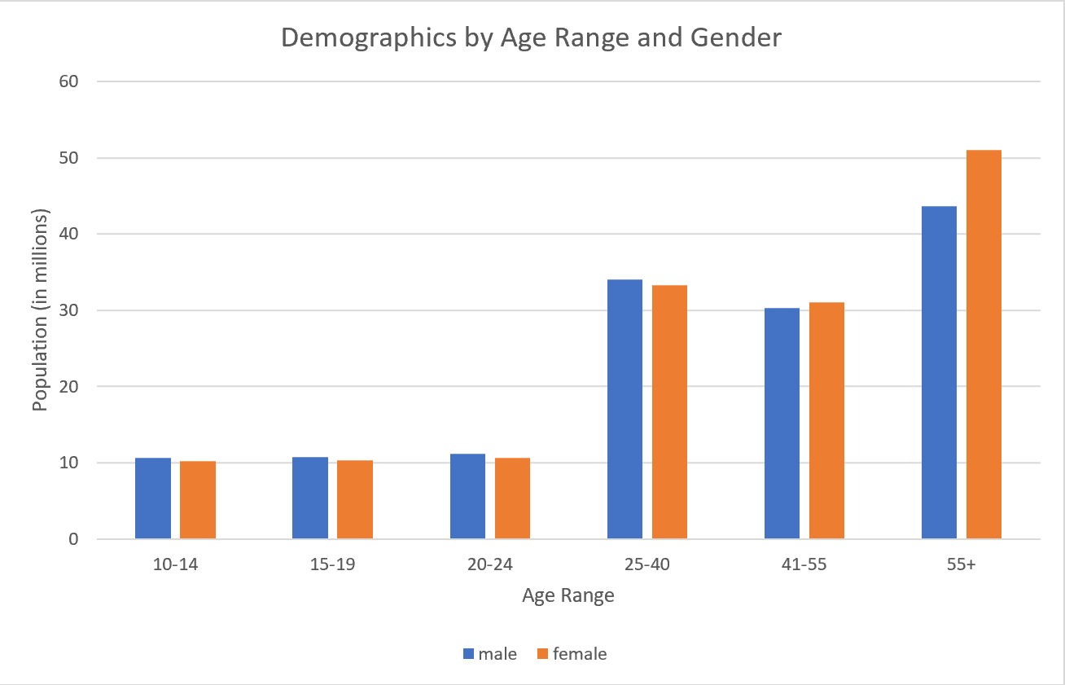**Demographics percentage by age range categories**

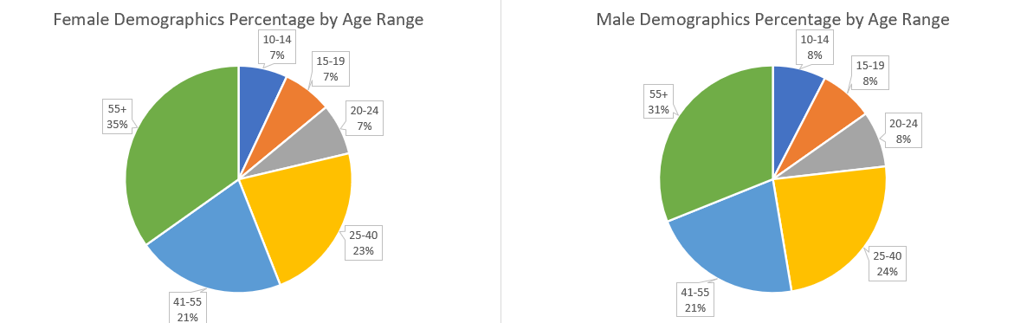

* **Data source:**
  + [statista.com](https://www.statista.com/statistics/241488/population-of-the-us-by-sex-and-age/)
  + Data Updated Date: 07/01/2018

#### Women in the U.S. financial-statement Statistics

Women purchase power in the U.S.([source](https://girlpowermarketing.com/statistics-purchasing-power-women/))

**Single women** across all income brackets spent, on average, **$34,817** on goods and services in 2017–2018. ([source](https://www.catalyst.org/research/buying-power/))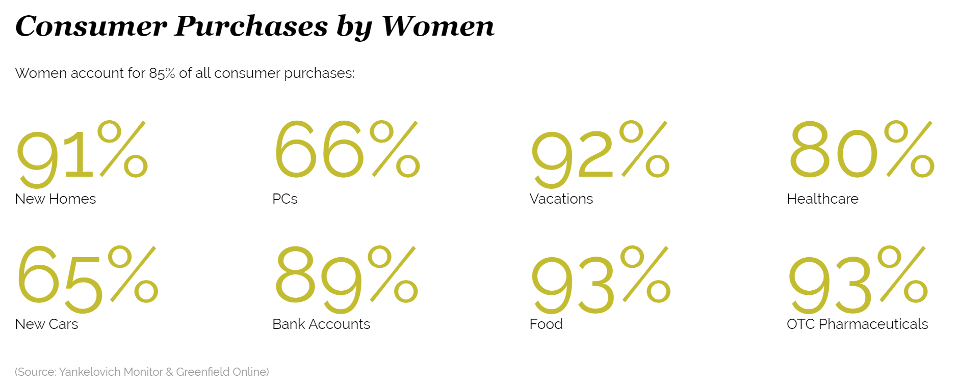

**Working married women** contributed over a third (37.1%) of their families’ incomes in 2017. ([source](https://www.catalyst.org/research/buying-power/))

##### 

##### **Pandemic impacts on women**

##### The Covid-19 pandemic will have a **disproportionately negative effect** on women. ([source](https://www.nytimes.com/2020/03/31/us/equal-pay-coronavirus-economic-impact.html))

* 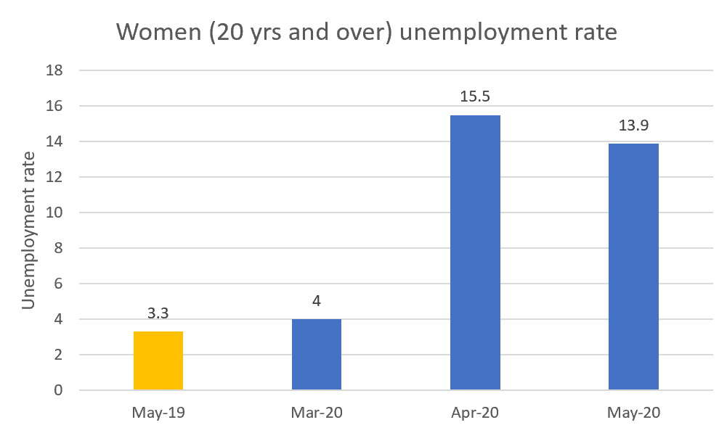Women **unemployment rate** since **March 2020**
* According to this (rough) classification, **17%** of employed women work in critical occupations, compared to **24%** of all employed men
  + women are more likely to be laid off in the pandemic
* Women make up **2/3 of the nearly 20million (~13 million)** workers in the low-wage workforce ([source](https://nwlc.org/wp-content/uploads/2015/08/final_nwlc_lowwagereport2014.pdf))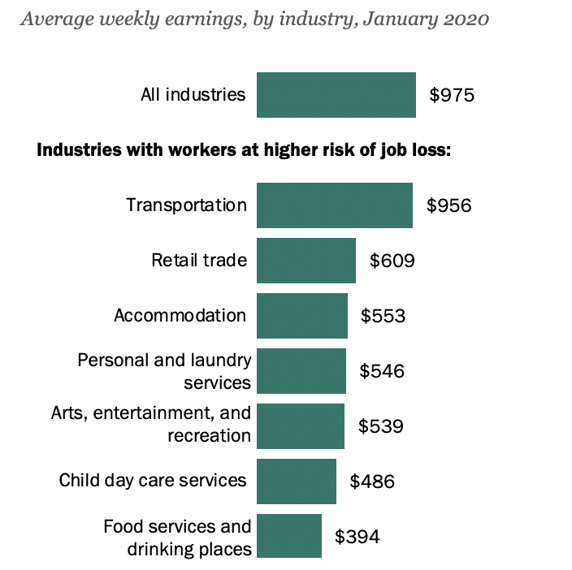
  + Most workers at a higher risk of job loss due to COVID-19 are low-wage workers ([source](https://www.pewresearch.org/fact-tank/2020/03/27/young-workers-likely-to-be-hard-hit-as-covid-19-strikes-a-blow-to-restaurants-and-other-service-sector-jobs/))

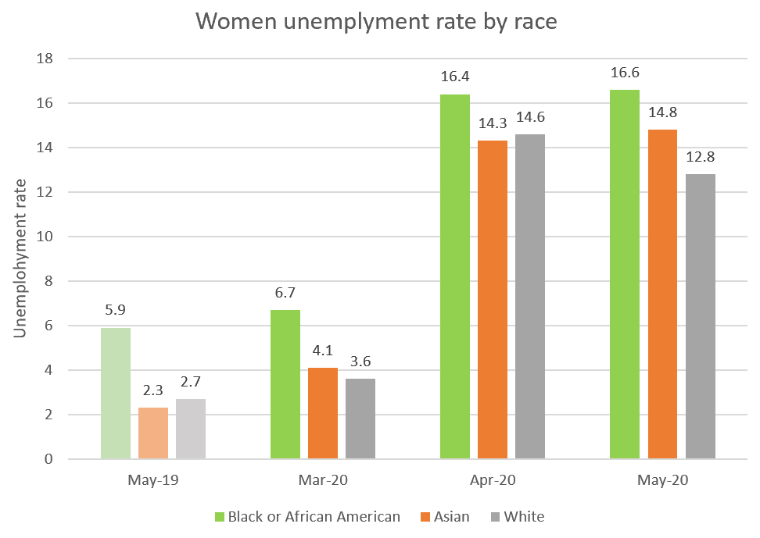

* Women unemployment claims since March 2020
  + between **7.8 and 8.4** million women filed for unemployment insurance in the three weeks ending April 4. ([source](https://www.epi.org/blog/women-have-been-hit-hard-by-the-coronavirus-labor-market-their-story-is-worse-than-industry-based-data-suggest/))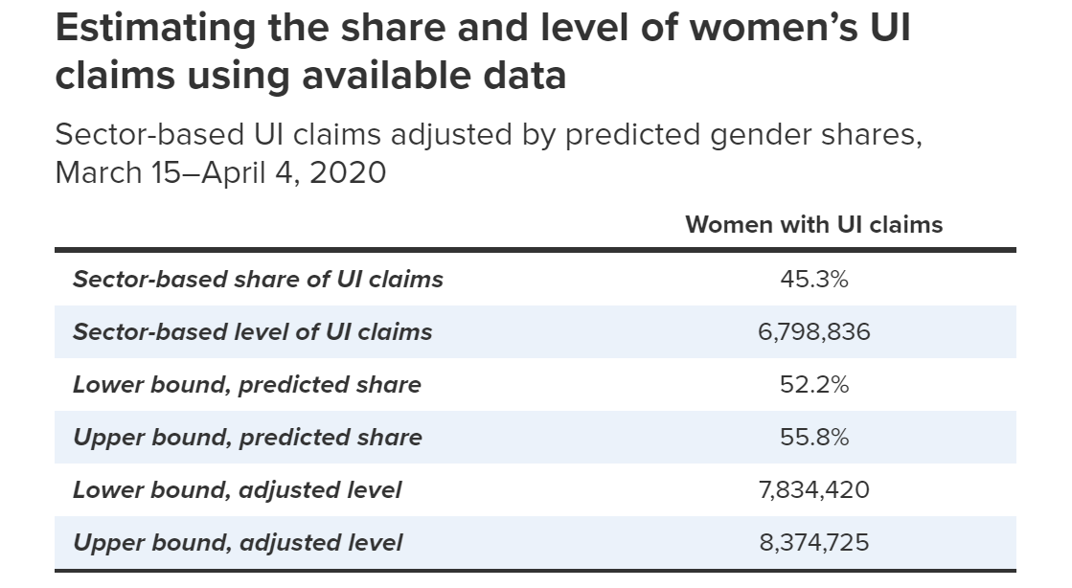
* The **majority of unemployment** applicants in states such as New York, New Jersey, Virginia, and Minnesota in mid- to late March were women ([source](https://www.theguardian.com/world/2020/apr/11/un-coronavirus-pandemic-gender-inequalities-women))

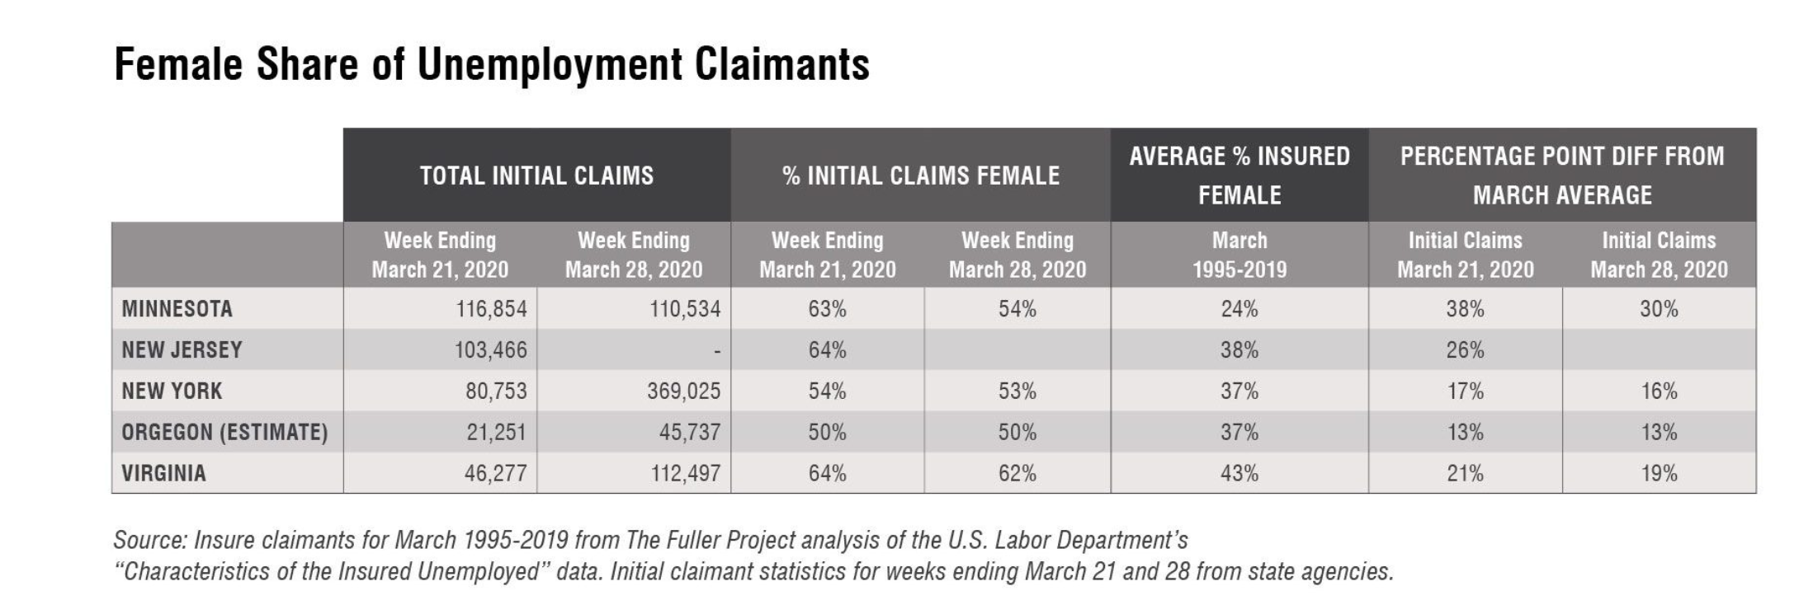

#### Overall buying power by age categories

##### **Pre-teens & Teens (13-18 years old)**

* Demographics**: ~25 million (**[**source**](https://www.ypulse.com/article/2020/01/09/millennials-gen-z-teens-combined-spending-power-is-nearly-3-trillion-in-2020/)**)**
* Total yearly spending power in 2020: **$34 billion (**[**source**](https://www.ypulse.com/article/2020/01/09/millennials-gen-z-teens-combined-spending-power-is-nearly-3-trillion-in-2020/)**)**
* Average monthly spending in 2020: **$115 (**[**source**](https://www.ypulse.com/article/2020/01/09/millennials-gen-z-teens-combined-spending-power-is-nearly-3-trillion-in-2020/)**)**
* Teens streams of income: [(source)](https://www.lexingtonlaw.com/blog/credit-cards/teen-spending-habits.html)
  + **22%** earn money by working a job
  + **50%** of teens who work outside of the home earn an average of **$465/month**
  + **64%** of teens depended on gifts for spending money
  + **32%** of teens received allowances for doing chores
* Consumer characteristics & shopping values: [(source)](http://www.fona.com/wp-content/uploads/2019/02/0219-FONA-Teens-Purchase-Power_v2.pdf)
  + **Curious:** Constantly online and social, they’re passionate about their unique hobbies and interests: finding, sharing, and seeking inspiration
  + **Savvy**: Gathering information, and sifting through it to find sources and products they trust is second nature to them
  + **Risk-averse:** More likely to follow brands that are well-reviewed by friends, because it’s also financially risky to stray too far from a trusted brand
  + **Diversity:** Gen Z teens are more racially diverse than Millennials. Not only do they make up various backgrounds and cultures, but they’re also interested in connecting with people of different shapes, sizes, and abilities
  + **Sustainability:** Considering food waste, packaging, fair trade, food production, plant-based food alternatives, and human labor.
  + **Parent’s choice influencers:** They become major influencers of their parents’ choices at the grocery store and in the kitchen
* Spending categories([source](https://www.ypulse.com/article/2020/01/09/millennials-gen-z-teens-combined-spending-power-is-nearly-3-trillion-in-2020/))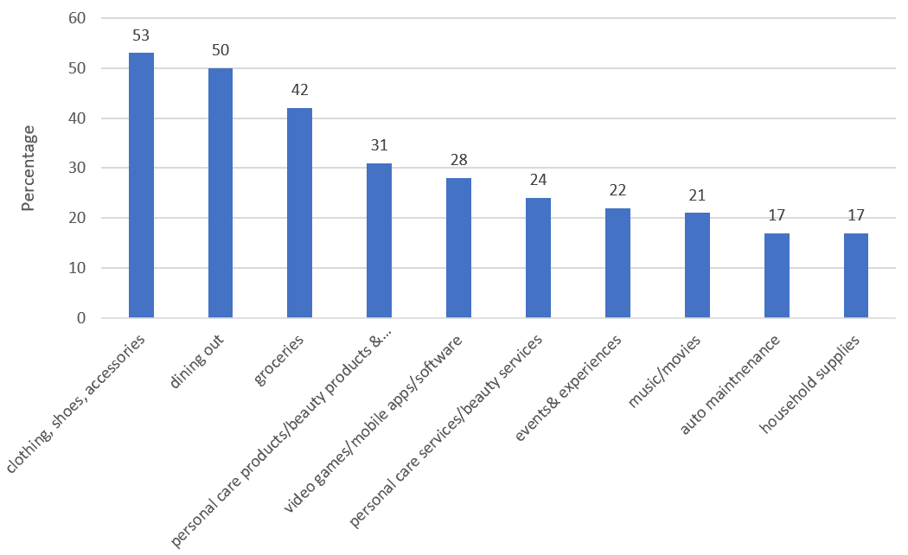

##### Entertainment/social media habits([source](https://smartsocial.com/social-media-statistics/#:~:text=The%20latest%20teen%20social%20media%20statistics&text=In%20just%20four%20years%2C%20that,the%20number%20climbed%20to%2084%25&text=American%20teens%2C%20ages%2013%20to,minutes%20each%20day%20in%202019))

* + Average screen time: 7 hours 22 minutes
  + Top social media app: youtube, instagram, snapchat
    - * Tiktok is **the fastest growing** new app, **60%** of tiktok users are 16-24 years old.

##### **Students attend post-secondary institutions**

* Demographics:
  + **~18.2 million** enrollments as of Fall 2019 ([source](https://educationdata.org/college-enrollment-statistics/))
    - **~11 million** were between age 18-24
    - **~6.1 million** were over the age of 24
  + **In 2018, 7.3 million** are male students
  + **In 2018, 9.4 million** are female students
* Total yearly spending power in 2019: **~$260 billion** ([source](https://www.refuelagency.com/blog/teens-shop-instore/))
* Average weekly spending in 2019 ([source](https://collegesteps.wf.com/college-student-spending/))
* Student streams of income: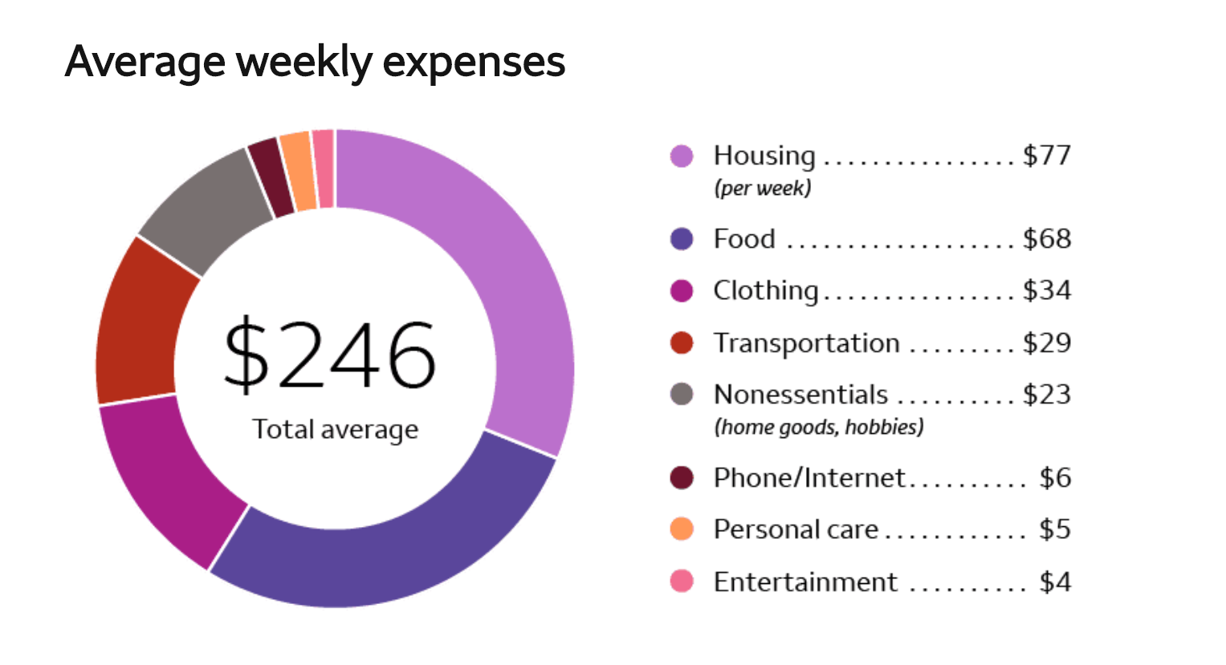
  + **67%** of college students received $2,000 or less annually from their parents in 2018. ([source](https://www.opploans.com/oppu/articles/are-college-millennials-responsible-with-their-parents-money/))
  + **44%** of students in college worked every year they were in school in 2018.
  + **86%** of college students worked summer jobs in 2018.
  + College students spend an average of **4.2 hours** working every day. ([source](https://www.us.hsbc.com/content/dam/hsbc/us/en_us/value-of-education/HSBC_VOE5_USA_FactSheet_508r2.pdf))
* 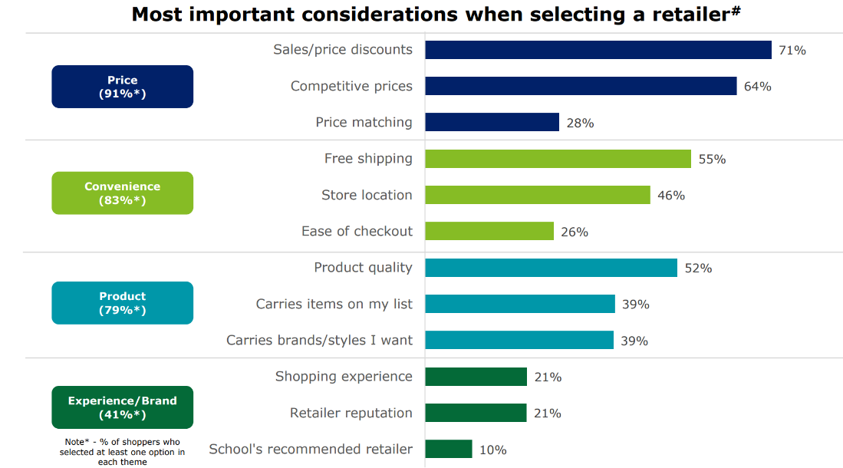Back to school shopping considerations when selecting a retailed store ([source](https://www2.deloitte.com/content/dam/Deloitte/us/Documents/consumer-business/us-cb-2019-back-to-college-report.pdf))
* College students’ recreational money spending percentage by categories ([source](https://www.opploans.com/oppu/articles/are-college-millennials-responsible-with-their-parents-money/))

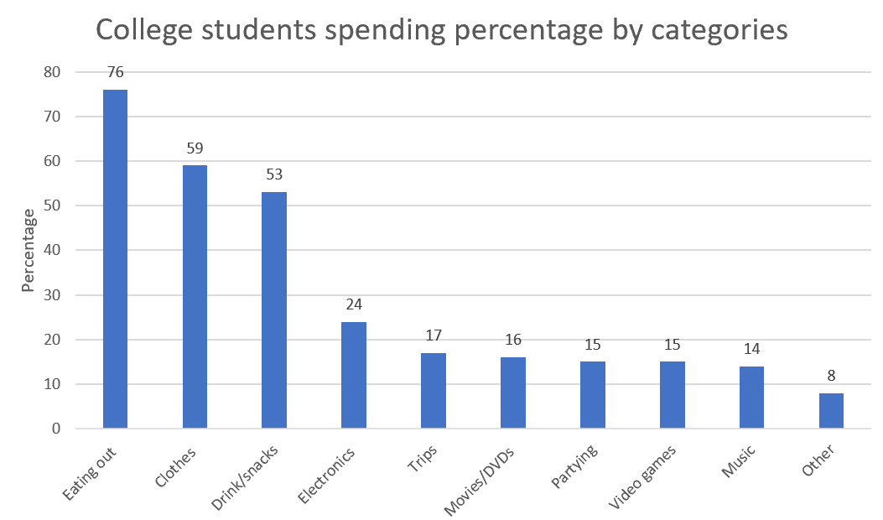

##### 

##### 

##### 

##### 

##### **Young professionals (millennials, age between 22-36 years old)**

* Demographics:
  + **83.1 million**, the largest generation in the U.S. ([source](https://www.forbes.com/sites/forbesbooksauthors/2019/05/01/millennial-spending-habits-and-why-they-buy/#68c33b33740b))
  + **Over 40%** of Millennials are parents. [[Source: Think With Google](https://www.thinkwithgoogle.com/consumer-insights/marketing-millennial-parents-youtube-insights/)]
  + **34%** of Millennials have a bachelor’s degree or higher. [[Source: Pew Research Center](http://www.pewsocialtrends.org/2014/02/11/the-rising-cost-of-not-going-to-college/)]
* Average yearly spending expenditure in 2019: **$47,112 (**[**source**](https://www.lexingtonlaw.com/blog/credit-cards/millennial-spending-habits.html)**)**
* Total yearly spending as a whole in 2019: **$600 billion**
* Consumer characteristics & shopping values:
  + Social responsibility
  + Environmental friendliness
  + Value price over recommendation: They focus on discounts
  + Shopping experience
* Social medial usage ([source](https://themanifest.com/social-media/how-different-generations-use-social-media#:~:text=Conversely%2C%20at%20least%2040%25%20of,but%20use%20that%20time%20differently.))
* 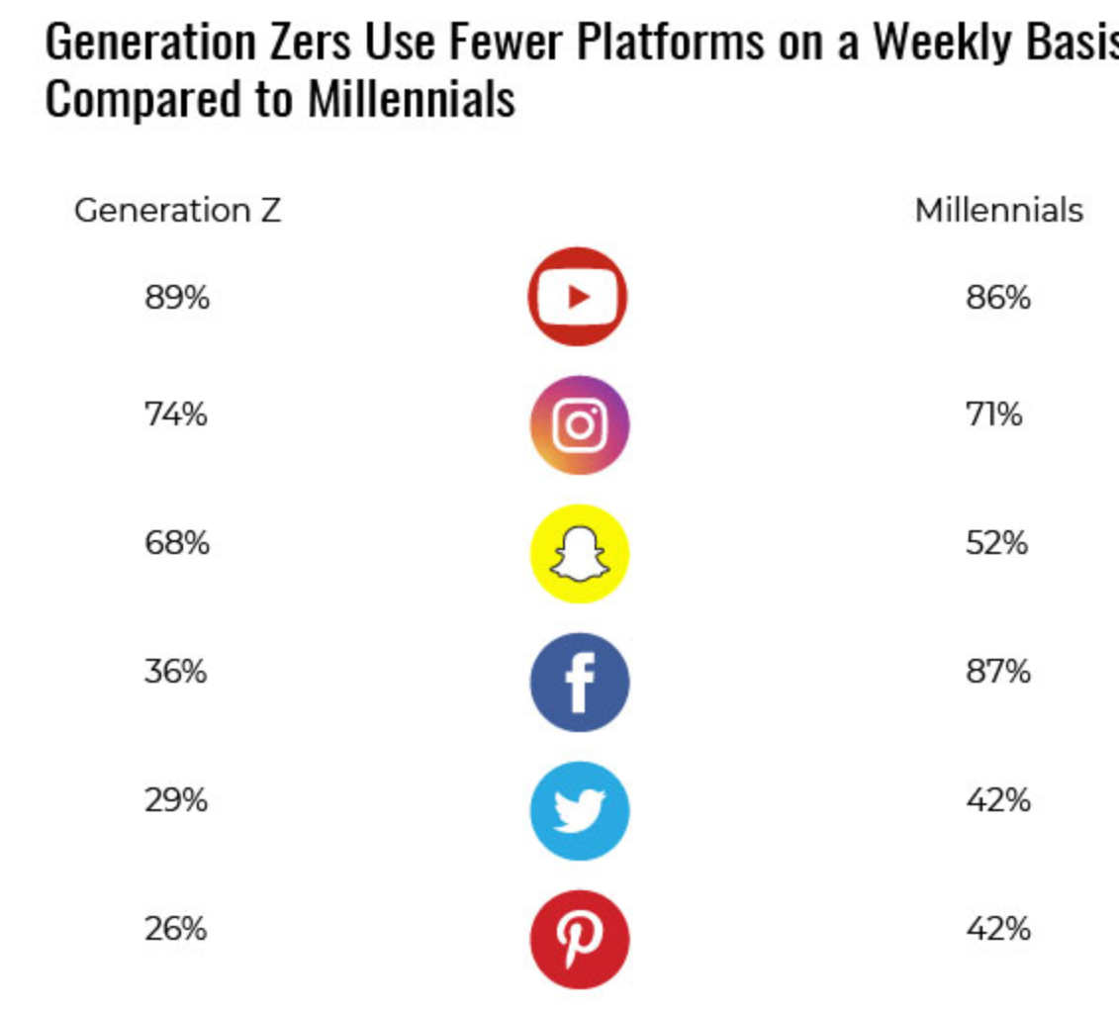

###### **Young women professionals**

* Millennial women’s purchase decision making ([source](https://www.marketingcharts.com/demographics-and-audiences/women-demographics-and-audiences-82773/attachment/merklelevo-top-influences-millennial-women-purchases-mar2018))
* 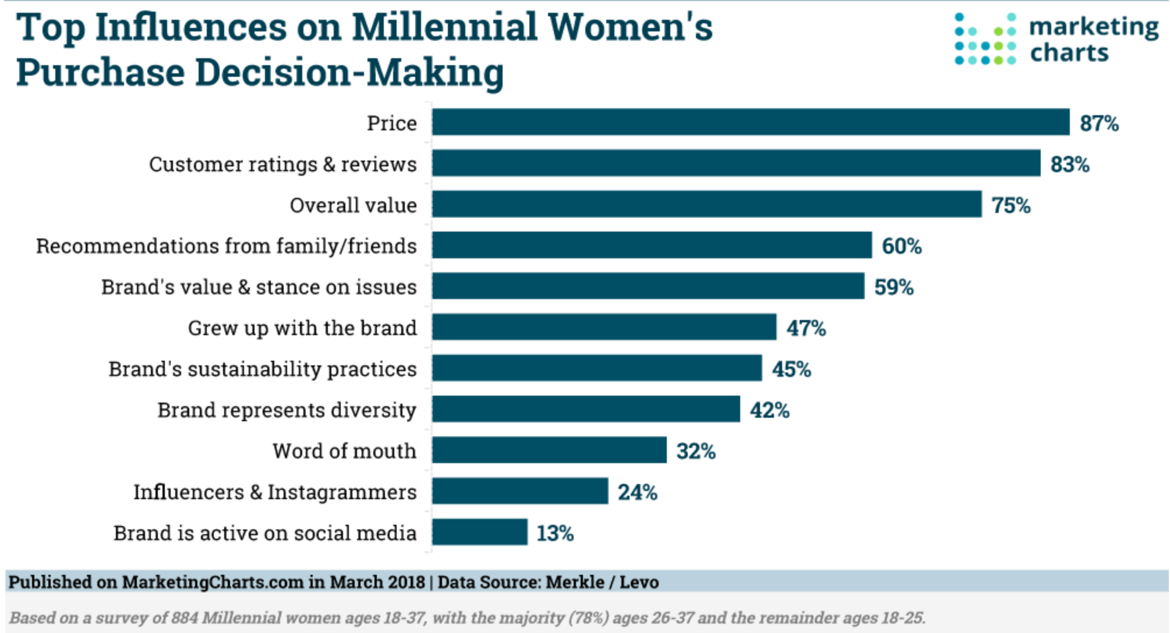

##### Spending comparison across generations ([source)](https://www.business2community.com/trends-news/consumer-shopping-trends-and-statistics-by-the-generation-gen-z-millennials-gen-x-boomers-and-the-silents-02220370)

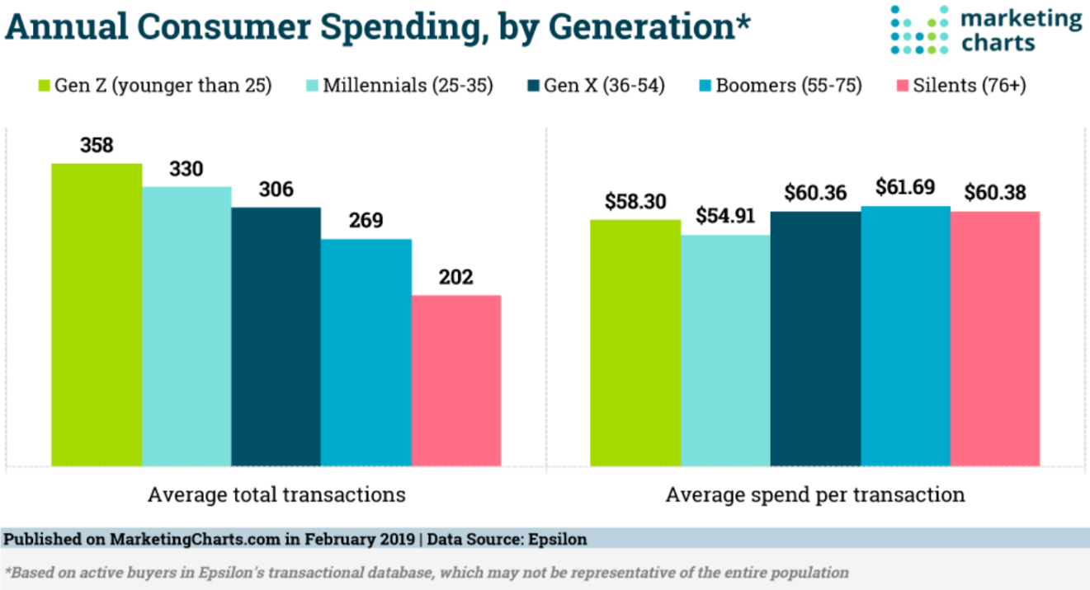

##### **Buying power break down by race**

* ([source](https://www.catalyst.org/research/buying-power/))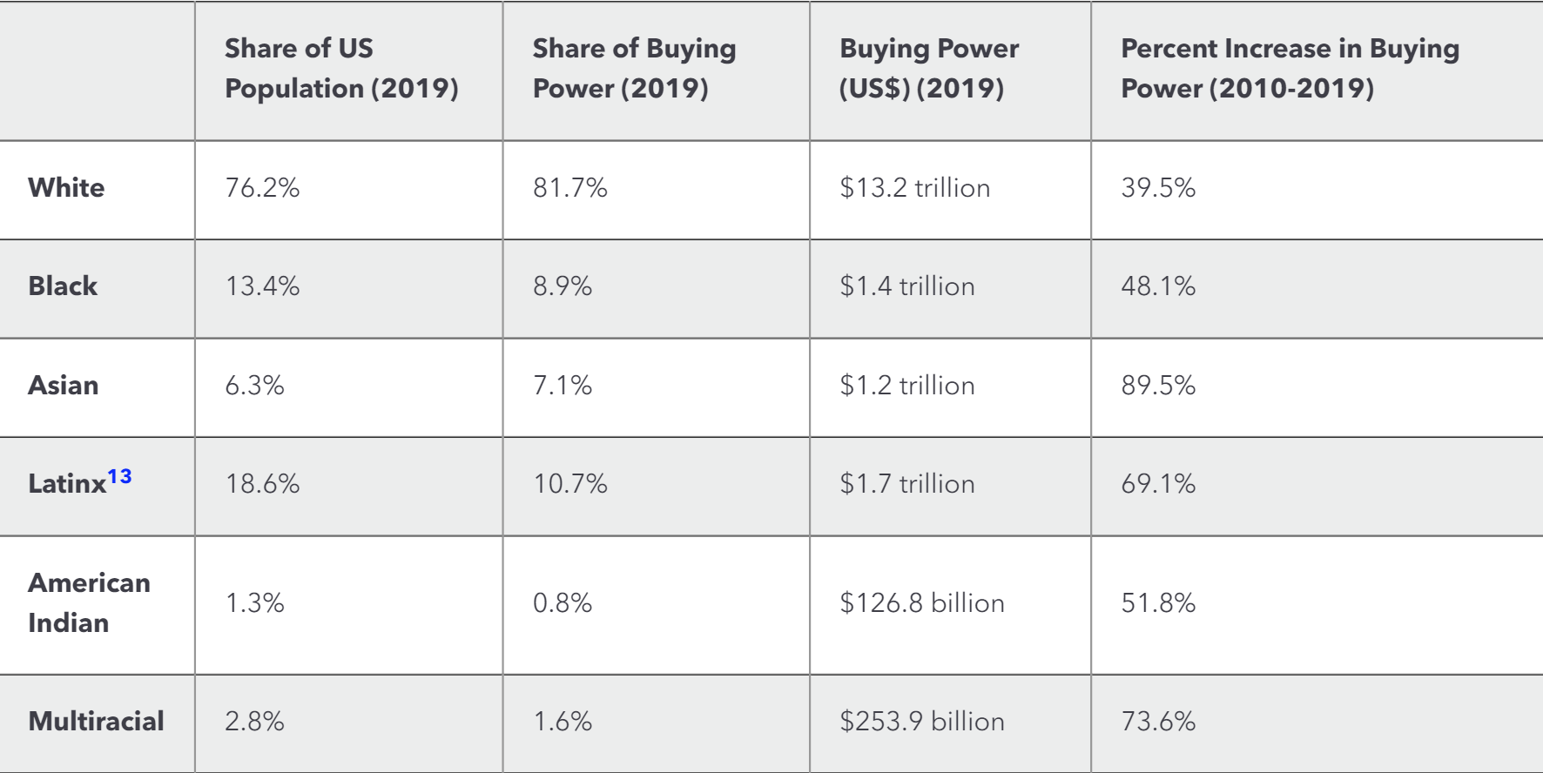

#### Online shopping:

* 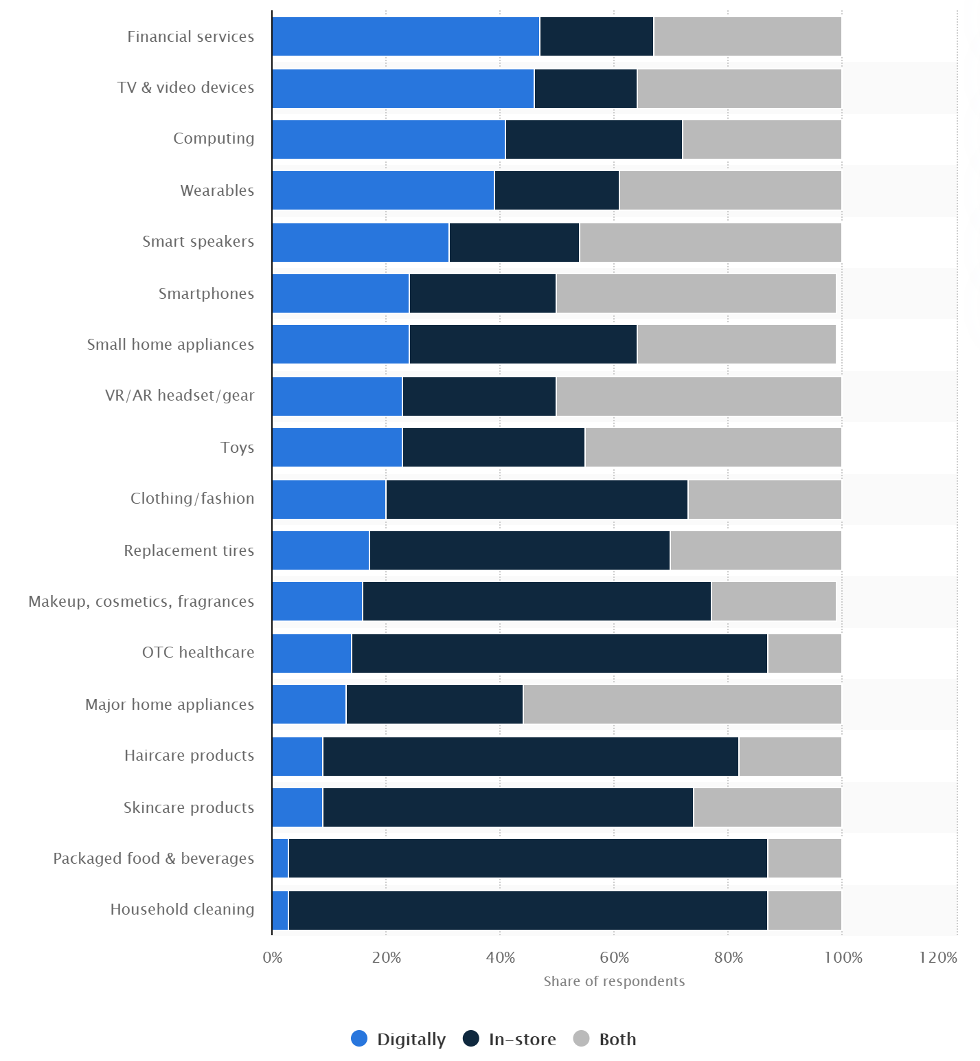Online vs. in-person shopping preferences in the U.S. 2019, by categories ([source](https://www.statista.com/statistics/311459/us-online-in-person-shopping-preferences-product-category/))
* Average online purchase amount per transaction as of **June 2019**([source](https://cdn.advocacy.sba.gov/wp-content/uploads/2017/05/22154543/Womens-Business-Ownership-in-the-US.pdfommerce%20Report%20-%20June%205,%202019.pdf))
* Ecommerce average order value, by country ([source](https://www.marketingcharts.com/charts/e-commerce-average-order-values-by-country/attachment/shopify-e-commerce-average-order-value-jul2019))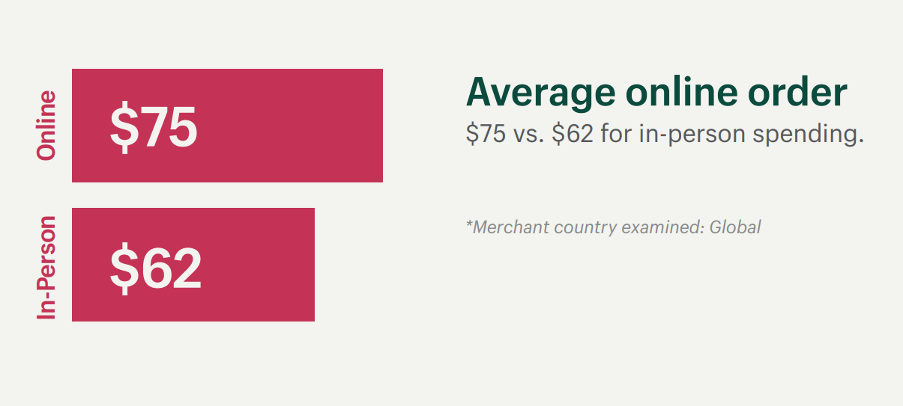

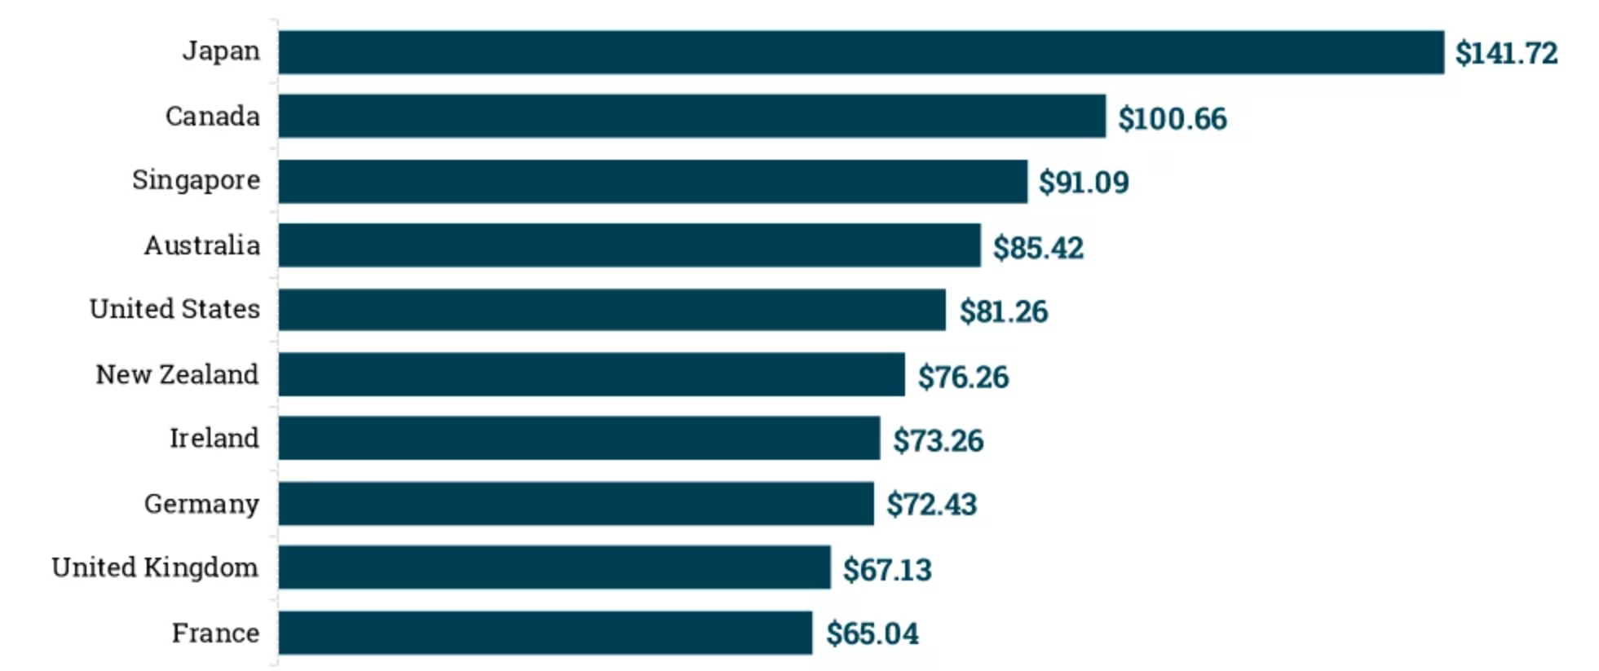

* **2020 First-quarter report**: (only captured 2 weeks of Covid)
  + Consumers spent **$146.47 billion online** with U.S. retailers, **up 14.5%** from $127.89 billion for the same period the prior year.
  + Online spending represented **16.2%** of total retail sales for the quarter. That was up from 15.0% for the same period in 2019.

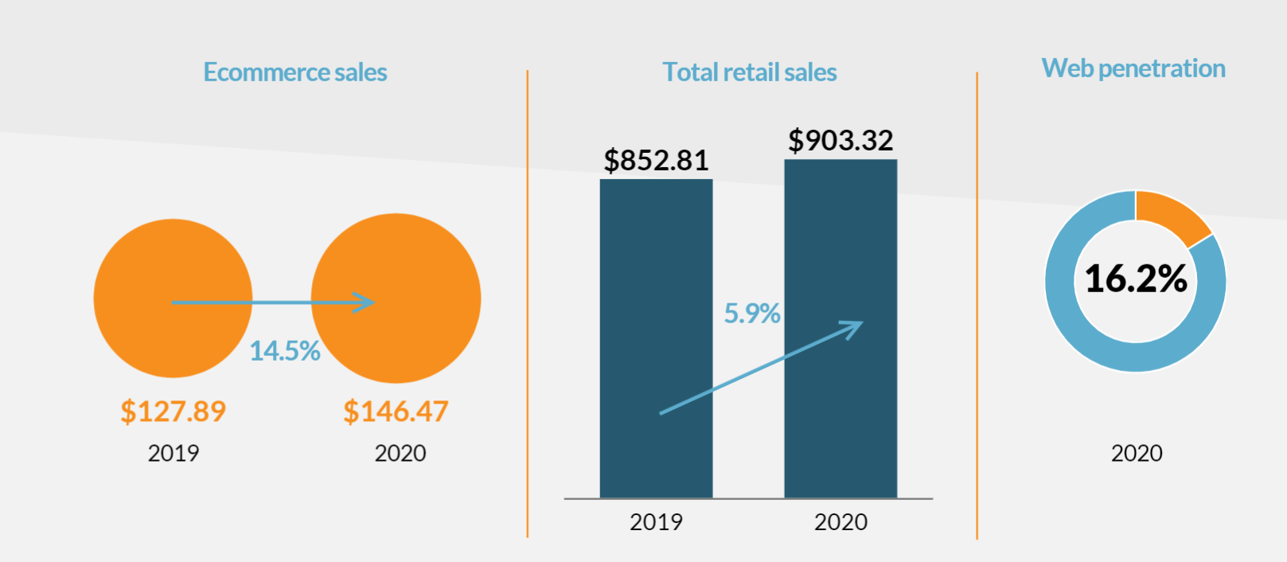

* 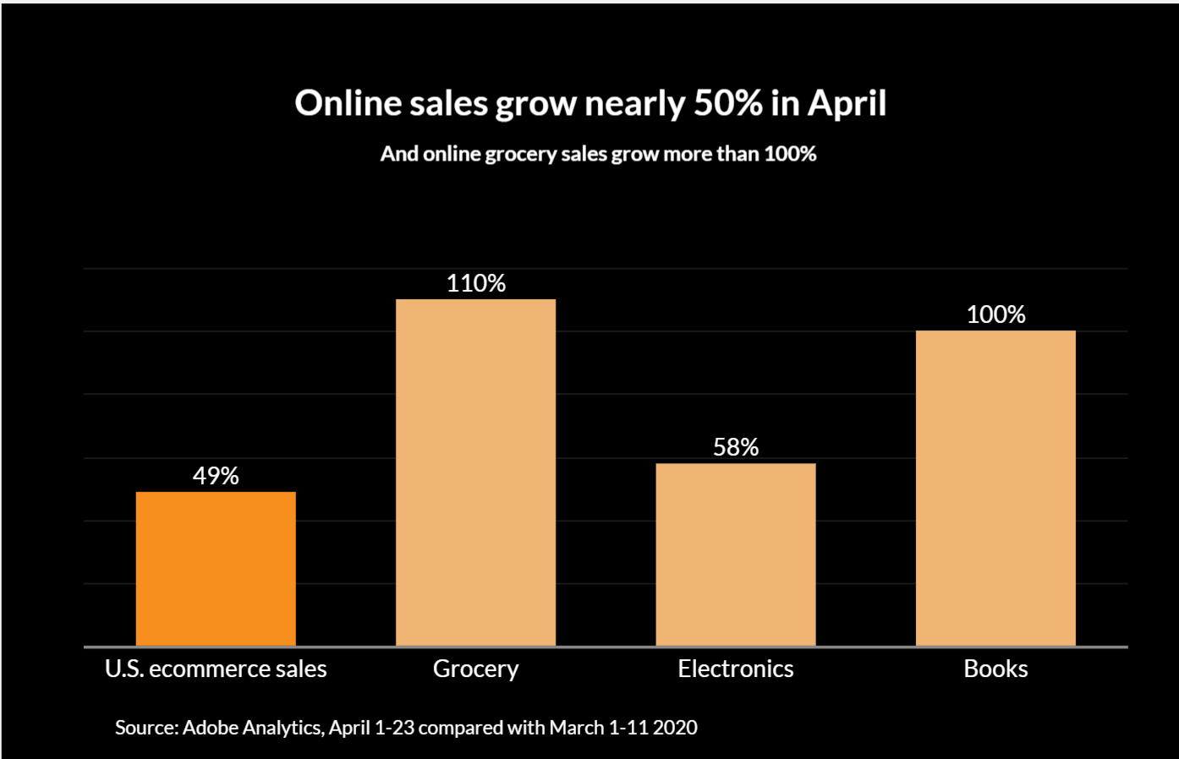**49% of online sales growth** in April 2020 ([source](https://www.digitalcommerce360.com/2020/05/20/ecommerce-during-coronavirus-pandemic-in-charts/))
* Increase in online grocery shopping 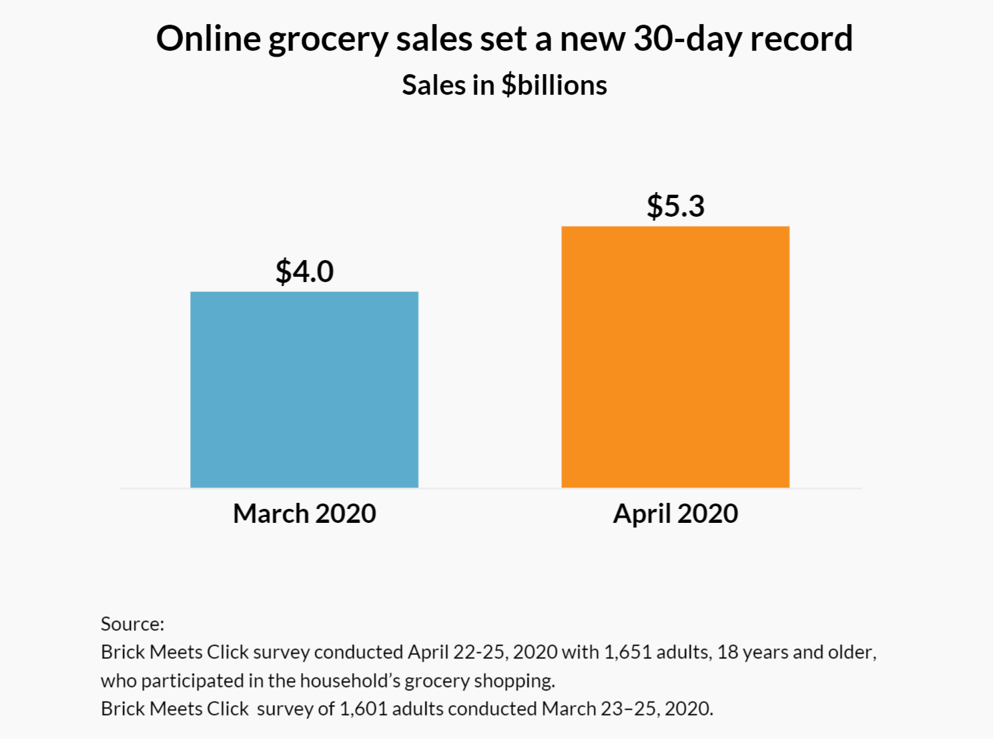
* More retailers report eCommerce **declines** in April than in March

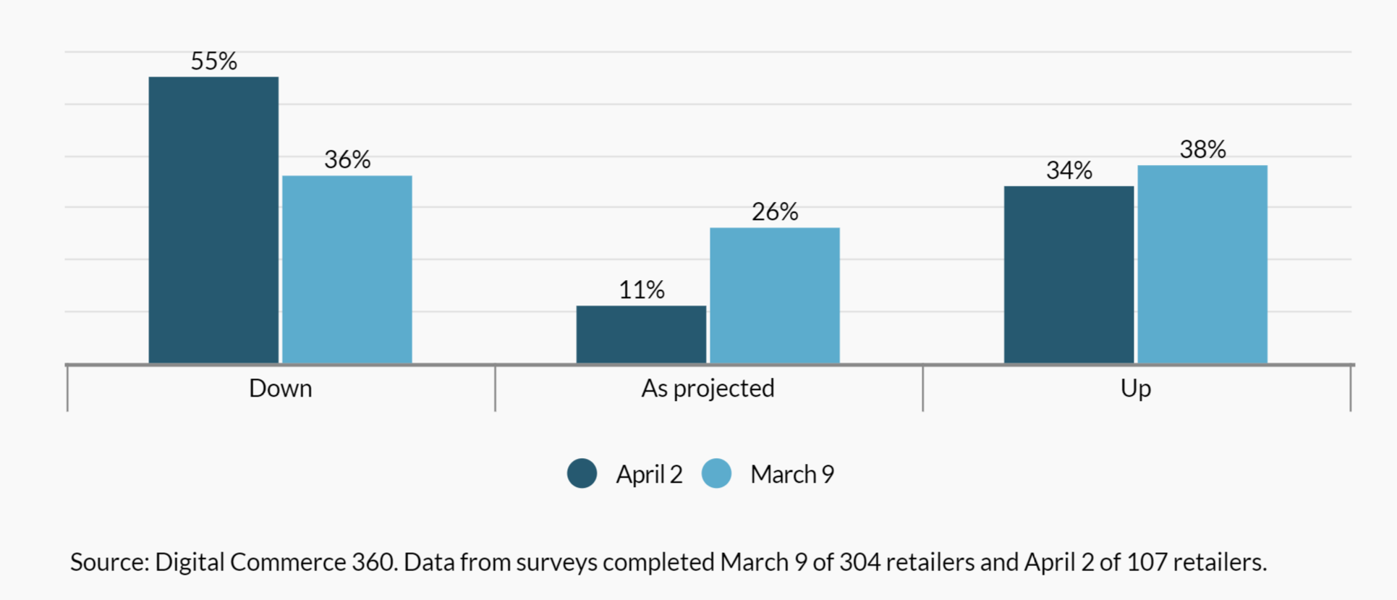

* Apparel sales **fell** in March, but are starting to **bounce back** in April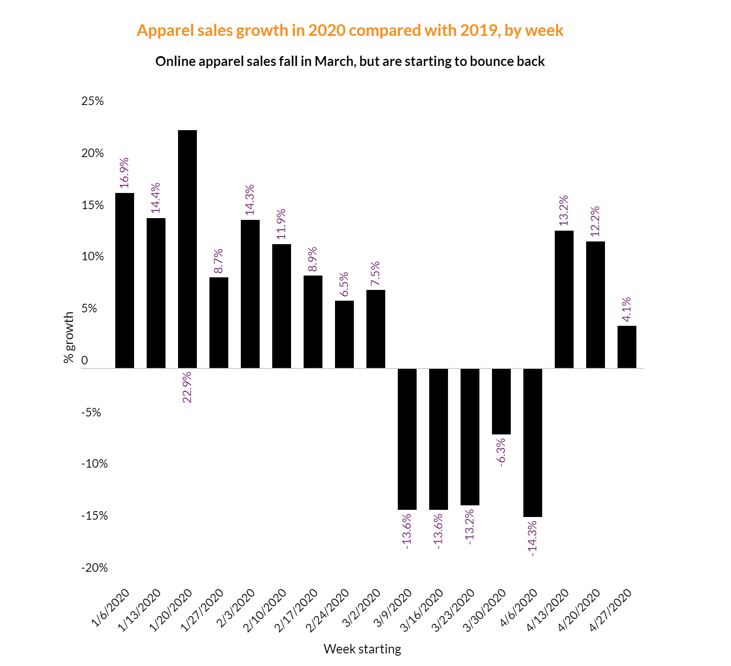
* 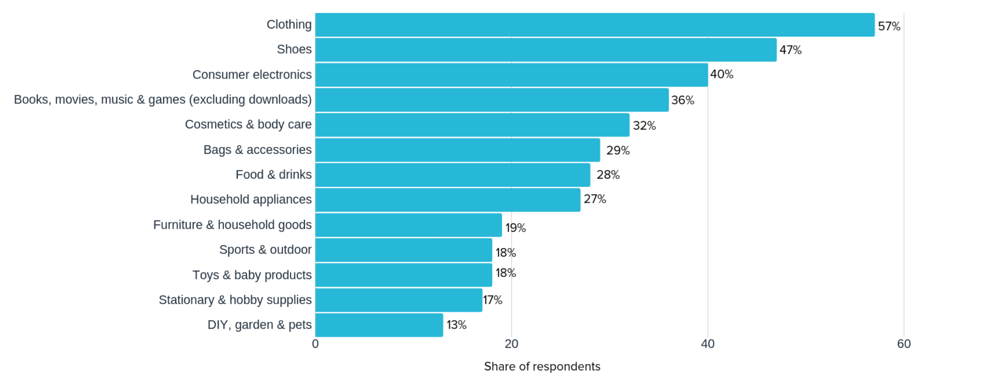Top online shopping categories ([source](https://www.oberlo.com/statistics/top-online-shopping-categories))

#### Some of women’s non-profits organizations

([source](https://www.entrepreneur.com/article/252925))

* [Movemeant Foundation](http://www.movemeantfoundation.com/)
  + Promote healthy body-image
* [Women for Women International](http://www.womenforwomen.org/) (WfWI)
  + Support marginalized women
* [Keep A Breast Foundation](http://www.keep-a-breast.org/) (KAB)
  + Breast cancer support and education
* [Special Olympics](http://www.specialolympics.org/)
  + the world’s largest sports organization for people with intellectual disabilities
* [Camp Kesem](http://campkesem.org/)
  + help families affected by cancer
* [The Malala Fund](https://www.malala.org/)
  + Young girls education and advocates for policy changes and resources that prioritize girl’s education
* Samahope
  + Funding doctors providing life-changing medical care
* [The National Organization for Women](http://now.org/) (NOW)
  + Largest feminist organization in the u.s.
* [Dressember](http://www.dressember.org/)
  + fund-raise for anti-trafficking efforts
* [Girls Who Code](http://girlswhocode.com/about-us/)
  + empower girls with the computer science education and skill sets needed to pursue 21st century opportunities
* some other organizations ([source](https://swirled.com/women-run-nonprofits/))

#### Women-owned businesses （defined as businesses that are at least 51% owned, operated and controlled by one or more females）

* There are **~13 million** women-owned businesses in the U.S. as of 2019 ([source](https://about.americanexpress.com/files/doc_library/file/2019-state-of-women-owned-businesses-report.pdf))
  + Increased by **21%** compared to 2014
* Total employment grew by 8% to **9.4 million** compared to 2014
* Revenue rose to 21% to **1.9 trillion** compared to 2014
* Firms percentage by size with gender comparison([source](https://cdn.advocacy.sba.gov/wp-content/uploads/2017/05/22154543/Womens-Business-Ownership-in-the-US.pdf))

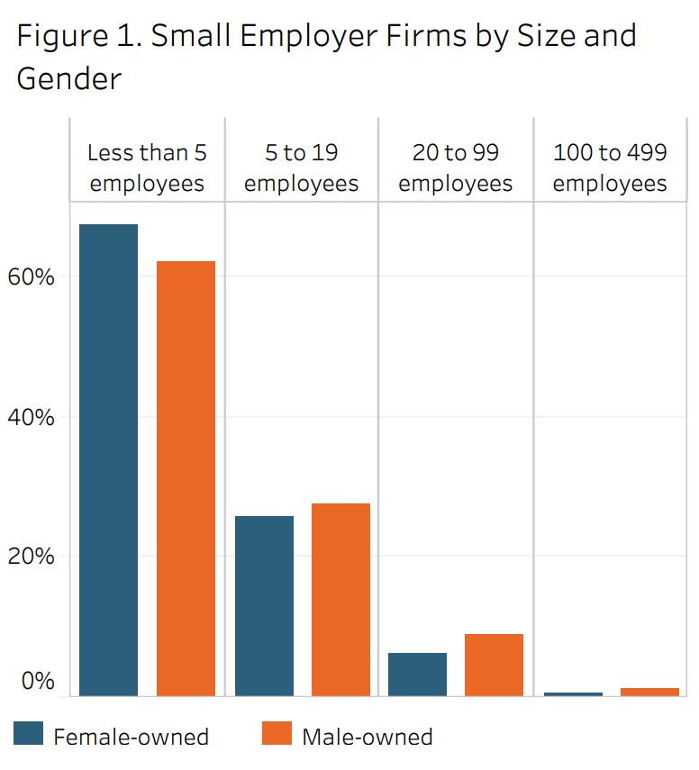

* Percentage of women business owners by **age group** ([source](https://about.americanexpress.com/files/doc_library/file/2018-state-of-women-owned-businesses-report.pdf))

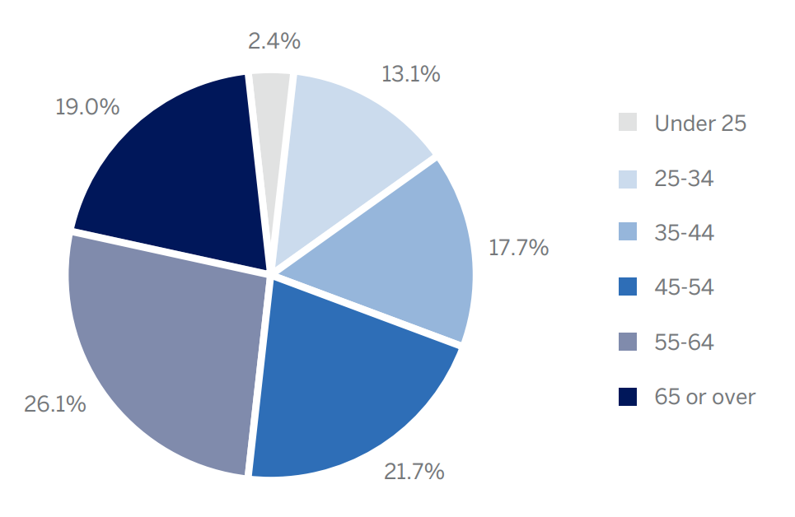

* Percentage of women business owners by age, race, and ethnicity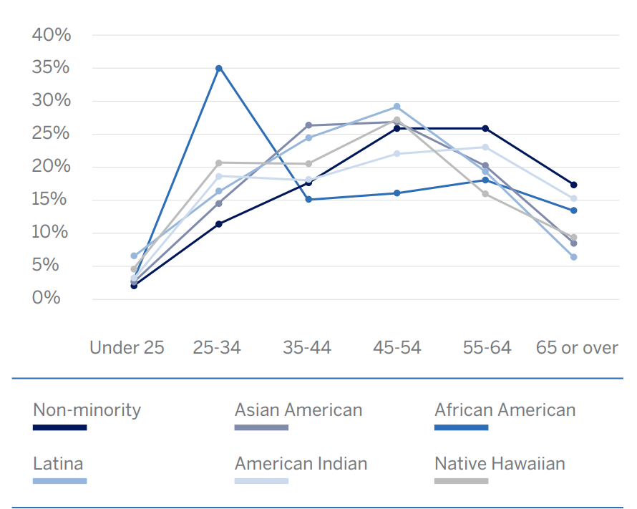
* Women-owned businesses concentrated industries

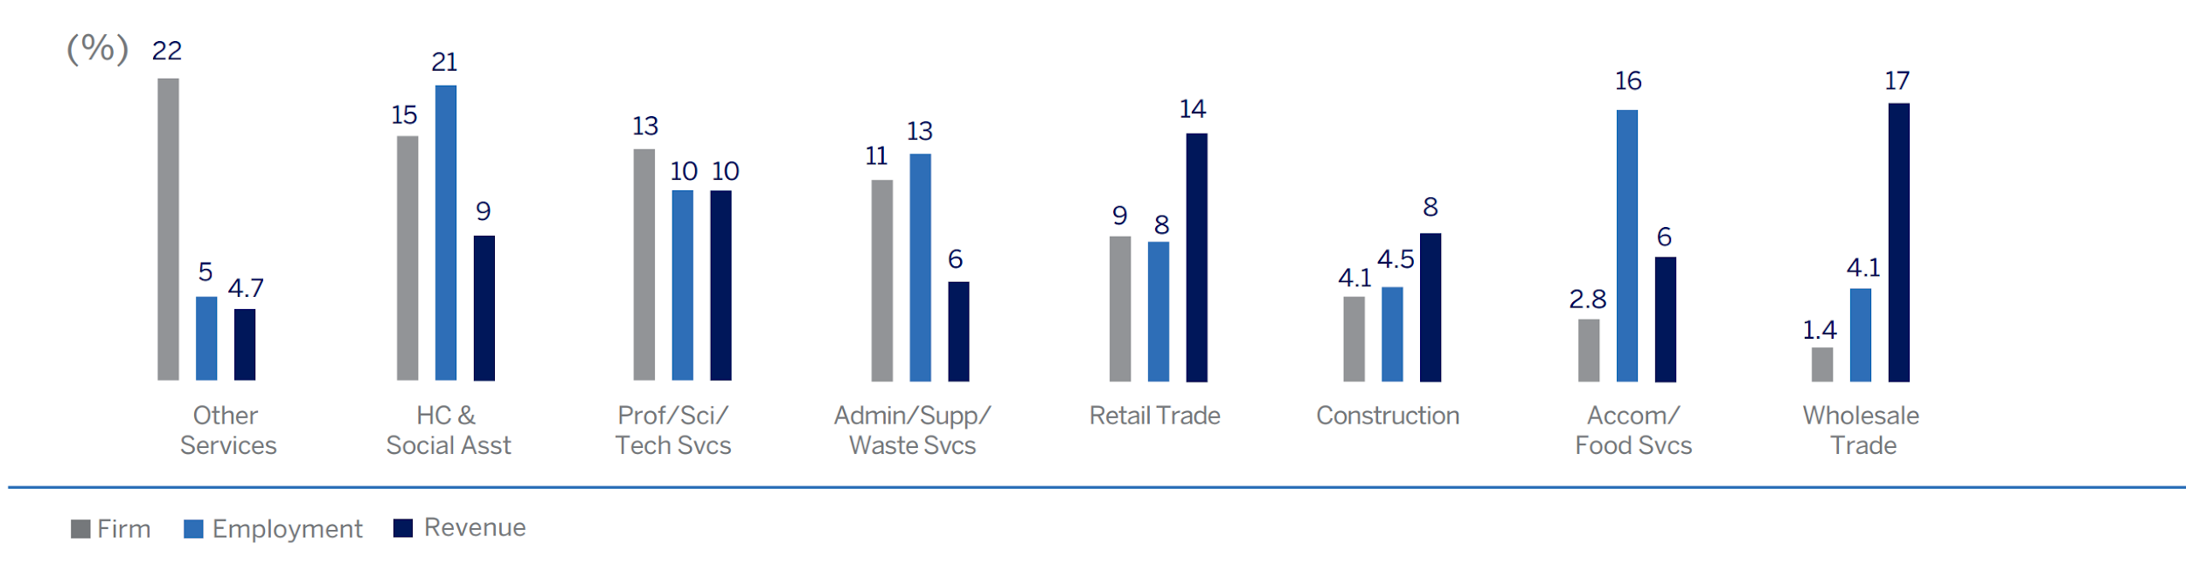

* **Half** of all women-owned businesses concentrated in **other services(hair and nail salons, pet care businesses)**, **healthcare and social assistance**, and **professional services/scientific/technical services**.
* **Other services:** 
  + From 2014 to 2019, the number of women owned businesses in the services category jumped from 29% from 2.2 million to 2.8 million.
* Growth of women-owned businesses in top industries by firm numbers, employment and revenue

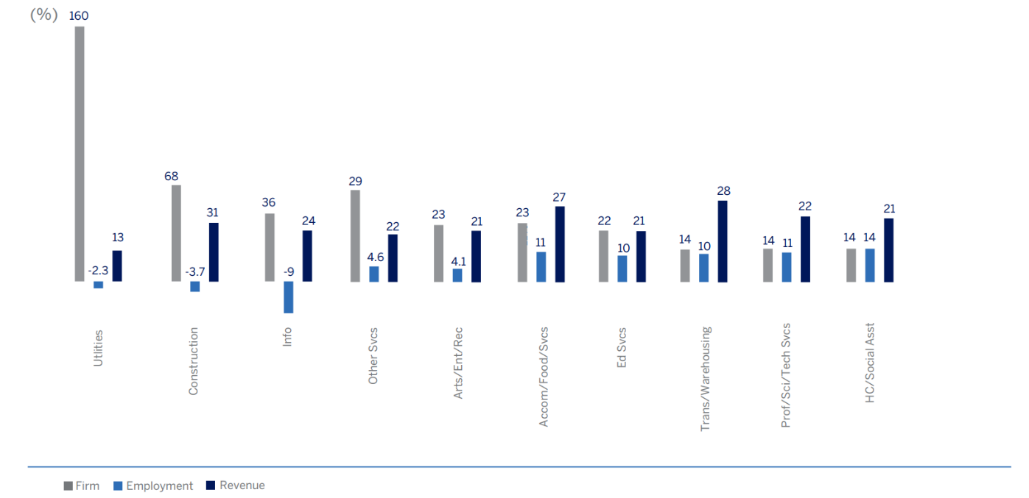

* Industries that have the most growth in the share of total employment by women-owned firms

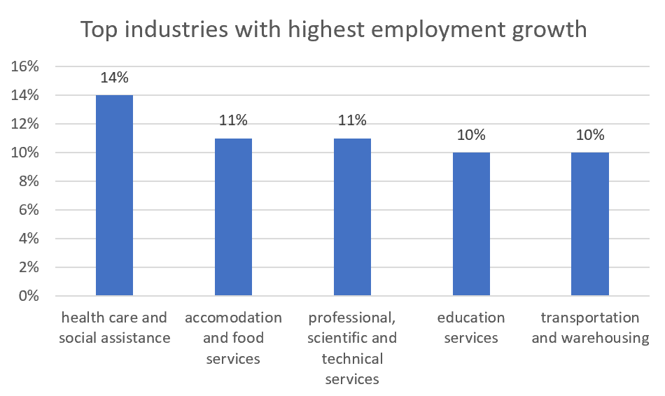

#### Women in top professional services

* women in top professional services (data collected from 2016 - now)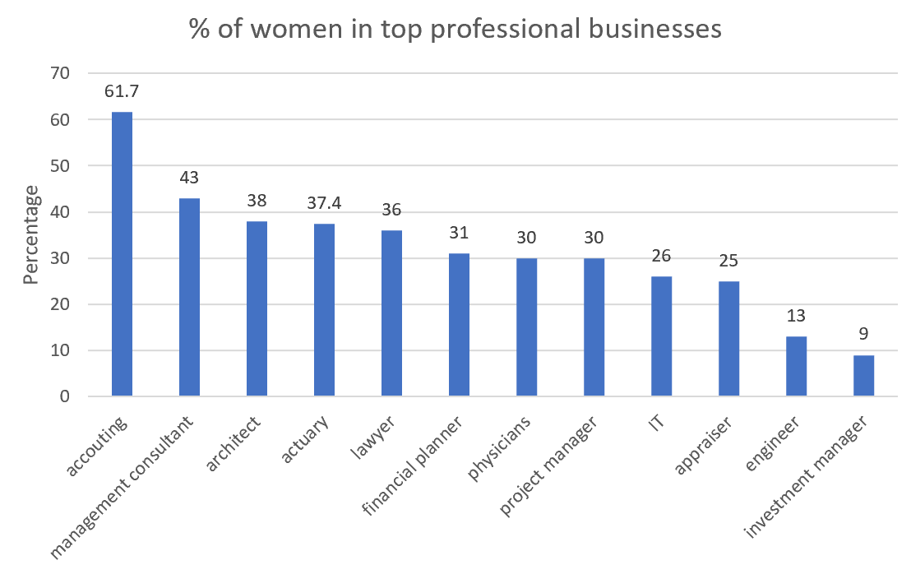

#### Supplemental Data table:

* **Demographics by age and gender**

|  |  |  |  |  |  |
| --- | --- | --- | --- | --- | --- |
| **age range** | **categories** | **male population (in millions)** | **female population (in millions)** | **female percentage** | **male percentage** |
| **10-14** | pre-teens | 10.66 | 10.22 | 6.98% | 7.58% |
| **15-19** | teens | 10.77 | 10.32 | 7.05% | 7.66% |
| **20-24** | young adults | 11.2 | 10.67 | 7.29% | 7.96% |
| **25-40** | adults | 34 | 33.25 | 22.70% | 24.17% |
| **41-55** | middle age | 30.34 | 31.01 | 21.17% | 21.57% |
| **55+** | senior | 43.7 | 50.99 | 34.81% | 31.07% |
| **total** |  | 140.67 | 146.46 | 100% | 100% |

* **Women unemployment rate after March 2020 (**[**source**](https://www.bls.gov/news.release/pdf/empsit.pdf)**)**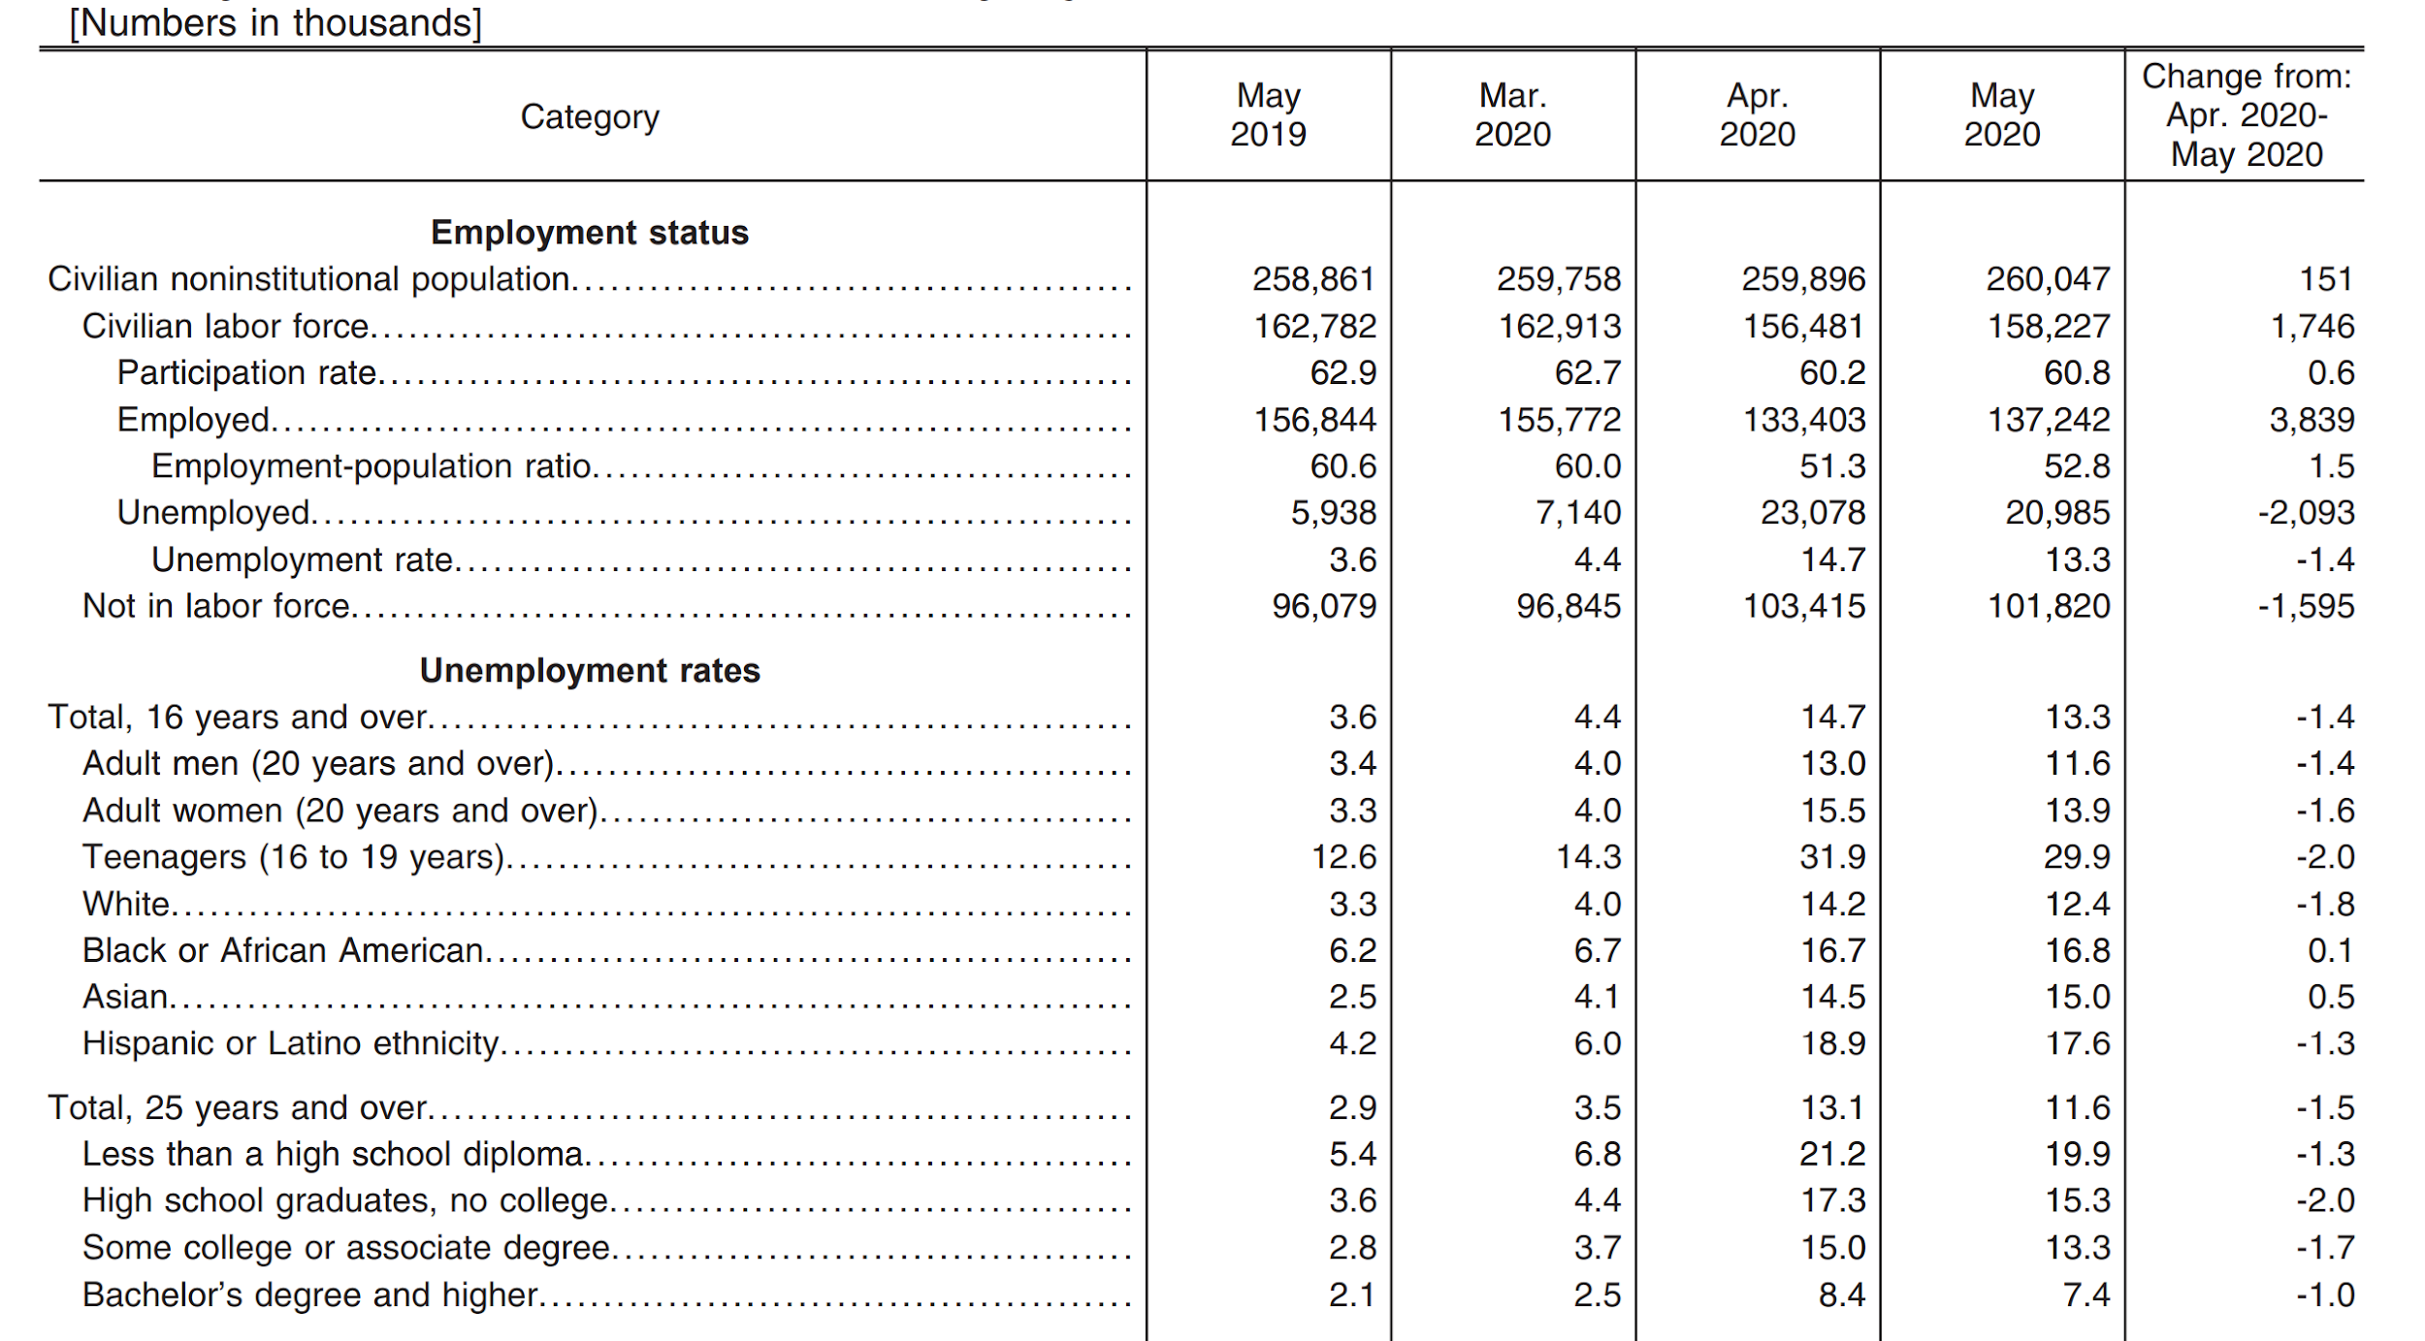
* **Women in professional sources:**
  + [**Appraiser**](https://www.mortgagewomenmagazine.com/industry/why-are-there-so-few-female-appraisers/#:~:text=In%20fact%2C%20according%20to%20figures,know%20the%20real%20estate%20market.)
  + [**Architect**](https://www.ncarb.org/nbtn2017/demographics#:~:text=Gender%20Equity%20Improves%20Along%20All%20Career%20Stages&text=In%202016%2C%20women%20accounted%20for,to%2034%20percent%20in%202015.)
  + [**Engineer**](https://alltogether.swe.org/2019/11/swe-research-update-women-in-engineering-by-the-numbers-nov-2019/)
  + [**Financial advisor**](https://www.cfp.net/-/media/files/cfp-board/knowledge/reports-and-research/womens-initiative/cfp-board_win_web.pdf)
  + [**Investment manager**](https://www.cnbc.com/2018/08/23/here-are-the-top-ranked-female-portfolio-managers-in-the-us.html#:~:text=Here%20are%20the%20top%2Dranked%20female%20portfolio%20managers%20in%20the%20US,-Published%20Thu%2C%20Aug&text=Globally%2C%20some%2010.3%20percent%20of,figure%20falls%20to%209%20percent.)
  + [**IT**](https://www.ncwit.org/resources/women-it-facts-infographic-2016-update)
  + [**Lawyer**](https://www.mycase.com/blog/2019/08/aba-2019-report-lawyer-demographics-earnings-tech-choices-and-more/)
  + [**Management consulting**](https://www.consulting.us/news/1150/us-management-consulting-firms-that-provide-women-a-top-culture#:~:text=In%20terms%20of%20percentage%20of,roles%20at%20the%20companies%2C%20respectively.) **(average over top companies)**
  + [**Physicians**](https://www.aamc.org/data-reports/workforce/interactive-data/active-physicians-sex-and-specialty-2015) **(average of all specialties)**
  + [**Project management**](https://www.cio.com/article/2895538/why-women-make-better-project-leaders-than-men.html#:~:text=On%20average%2C%20women%20hold%20about,than%20logic%20would%20otherwise%20dictate.)
  + **Women in actuary (**[**source**](https://datausa.io/profile/soc/actuaries)**)**

